**CHAPTER-1**

**INTRODUCTION**

**Antenna**

An antenna is a device used to transmit and receive electromagnetic signals. It is typically composed of metal elements that are designed to radiate or receive electromagnetic waves.

Antennas are used in various applications such as communication systems, radar systems, and wireless networks.

They play a crucial role in enabling the transmission and reception of signals over long distances. The design and characteristics of an antenna determine its efficiency and performance.

**Antenna Parameters**

1. **Frequency:**

* Frequency in antenna refers to the number of cycles or oscillations that occur in the electromagnetic wave being transmitted or received by the antenna.
* It is typically measured in Hertz (Hz), which represents the number of cycles per second.
* The frequency of an antenna determines its ability to transmit or receive signals of a specific wavelength.
* Different antennas are designed to operate at different frequencies, such as radio antennas for AM or FM frequencies, or satellite antennas for higher frequency bands.
* The frequency of an antenna is an important factor to consider when designing a wireless communication system, as it affects the range, bandwidth, and overall performance of the antenna

1. **Gain**

* Gain is a measure of how directional an antenna is. It is the ratio of the power radiated in the direction of the antenna's peak radiation to the power that would be radiated by an isotropic antenna (an antenna that radiates equally in all directions).
* Antenna gain is typically expressed in decibels relative to isotropic (dBi). For example, an antenna with a gain of 6 dBi radiates twice as much power in the direction of its peak radiation as an isotropic antenna.
* Antenna gain can be increased by making the antenna more directional. This can be done by increasing the antenna's size, using reflectors, or using arrays of antennas.
* Higher gain antennas are typically used for long-range communication. This is because they can focus the transmitted power in a narrower beam, which results in a stronger signal at the receiver.
* However, higher gain antennas also have a narrower beamwidth. This means that they are more sensitive to the direction of the receiver.

1. **Directivity**

* Directivity in antenna design is a measure of how concentrated the antenna's radiation is in a particular direction.
* Directivity is dimensionless and is typically expressed in decibels (dB). A higher directivity value indicates a more directional antenna.
* An isotropic antenna, which radiates equally in all directions, has a directivity of 1. All real antennas have a directivity greater than 1.
* Directivity is an important parameter for many antenna applications, such as point-to-point communication, radar, and satellite communication. A directional antenna can transmit or receive more power in a particular direction, which can improve the range and signal quality of the system.
* Directivity can be increased by using a larger antenna aperture or by using multiple antennas in an array.
* Directivity is a function of the antenna's geometry and operating frequency.

1. **Radiation pattern**

* The radiation pattern of an antenna is a graphical representation of the distribution of radiated energy into space, as a function of direction. It is typically plotted in either polar coordinates or rectangular coordinates.
* The radiation pattern can be used to determine the antenna's directivity, gain, and sidelobe levels.
* The radiation pattern is important for many antenna applications, such as point-to-point communication, radar, and satellite communication.

1. **Impedance**

* Impedance in antenna design is a measure of the opposition to the flow of current in an antenna. It is a complex quantity, consisting of both a real and an imaginary part. The real part of the impedance represents the power that is radiated by the antenna, while the imaginary part of the impedance represents the power that is stored in the antenna's near field.
* For maximum power transfer, the impedance of the antenna should be matched to the impedance of the feedline and the transmitter or receiver.

1. **Polarization**

* Polarization in antenna design is the orientation of the electric field (E-field) radiated by the antenna. It is typically described as either horizontal, vertical, or circular.
* Polarization can be used to reduce interference from other signals.
* **For example in** Satellite communication antennas are typically circularly polarized, because this reduces the effects of polarization mismatch between the transmitting and receiving antennas

1. **Bandwidth**

* The bandwidth of an antenna is determined by its geometry and operating frequency.
* A wider bandwidth antenna can be used to transmit or receive a wider range of frequencies.
* The bandwidth of an antenna is important for many applications, such as point-to-point communication, radar, and satellite communication.

1. **VSWR**

* VSWR is a dimensionless quantity, typically expressed in decibels (dB).
* A VSWR of 1 indicates a perfect match between the impedance of the antenna and the impedance of the feedline and the transmitter or receiver.
* A higher VSWR indicates a poorer match between the impedance of the antenna and the impedance of the feedline and the transmitter or receiver.
* Power loss: A high VSWR can cause power to be reflected back to the transmitter, which can reduce the efficiency of the antenna system.

1. **Axial ratio**

* Axial ratio is important for many antenna applications, such as satellite communication, radar, and GPS.
* A circularly polarized antenna can reduce interference from other signals and improve the reliability of communication links.
* Axial ratio can be affected by the antenna's geometry, operating frequency, and the presence of nearby objects.

1. **Near field**

* The near field is the region closest to the antenna, where the electromagnetic field is reactive and rapidly decaying.
* The near field is further divided into two subregions:
* The reactive near field: This region is closest to the antenna and is characterized by a strong reactive field.
* The radiating near field: This region is further away from the antenna and is characterized by a radiating field that is still rapidly decaying.

1. **Far field**

* The far field is the region furthest from the antenna, where the electromagnetic field is radiative and propagates with a constant amplitude.
* The far field is also known as the Fraunhofer region.

**ABOUT ANSYS HFSS SOFTWARE**

Ansys HFSS (High-Frequency Structure Simulator) is a 3D electromagnetic simulation software for designing and simulating high-frequency electronic products such as antennas, antenna arrays, high-speed interconnects, filters, connectors, IC components and packages and printed circuit boards.

* Model and simulate a wide variety of antenna types, including linear antennas, planar antennas, and aperture antennas.
* Analyze the antenna's radiation pattern, impedance, gain, and efficiency.
* Optimize the antenna's design for specific performance requirements.
* Troubleshoot antenna design problems.

**Here are some examples of how HFSS is used for antenna design:**

**Aerospace engineers** use HFSS to design antennas for aircraft, spacecraft, and missiles.

**Defense engineers**use HFSS to design antennas for radar systems, electronic warfare systems, and communication systems.

**Telecommunications engineers** use HFSS to design antennas for cellular base stations, satellite communication systems, and wireless networks.

**Tasks**

1. Creating a design of Microstrip Rectangular Patch Antenna in HFSS for operating frequency(f)=33.5GHz, display all the resulting parameters [1].

2. Creating a design of MIMO (Multiple Input and Multiple Output) microstrip patch antenna array design in HFSS for frequency(f)=34GHz, display all the resulting parameters [1].

3. Creating a design of Circularly polarized parasitic strips for frequency(f)= in HFSS, display all the resulting parameter [1].

Task 1: Creating a design of Microstrip Rectangular Patch Antenna in HFSS for operating frequency(f)=33.5GHz, display all the resulting parameters.

**TABLE 1:** Obtained and optimized values of design parameters [1]

|  |  |  |  |
| --- | --- | --- | --- |
| Design Parameters | Description | Obtained values from Calculation(mm) | Optimized values for Performance(mm) |
| Wp | Width of patch | 3.386 | 3.62 |
| Lp | Length of patch | 2.551 | 2.45 |
| Wg | Width of substrate and ground plane | 5.49 | 6 |
| Lg | Length of substrate and ground plane | 4.65 | 6 |
| Wf | Width of feed line | 0.46 | 0.46 |
| Lf | Length of feed line | 1.57 | 1.57 |

* **Design parameters of proposed MPA**

The basic microstrip patch antenna has a patch, substrate, ground plane, and feed line and these portion’s geometrical designs are calculated by utilizing the Maxwell equation. These equations are introduced by maxwell who combined the theory of magnetism and electricity. For the design, RT-Duroid 5880 material is used as substrate which has the dielectric constant value "r is 2.2 and the thickness of the substrate h is 0.5 mm. Every antenna requires the resonance frequency for the process and the proposed work is utilizing 33.5 GHz as the resonance frequency which is more preferable for the 5G wireless communication. The design parameters of the microstrip patch antenna are calculated by utilizing the following equations [1].

**Steps:**

1. Firstly launch HFSS software and create a new project.
2. Draw the rectangular patch antenna with the desired dimensions.
3. Add a ground plane beneath the patch and ensure it extends beyond the patch edges.
4. Define the substrate dimensions and place a patch on the substrate.
5. Specify the substrate material properties such as relative permittivity(ℇr).
6. Specify the substrate thickness(h) and the height of the substrate above the ground plane.
7. Add a Microstrip line as a feeding structure to excite the patch, and define the width and position of the feed line.
8. Set up the simulation settings, including the frequency range, type of analysis, and desired results.
9. Run the simulation and extract the parameters like resonant frequency, gain, bandwidth, and so on.

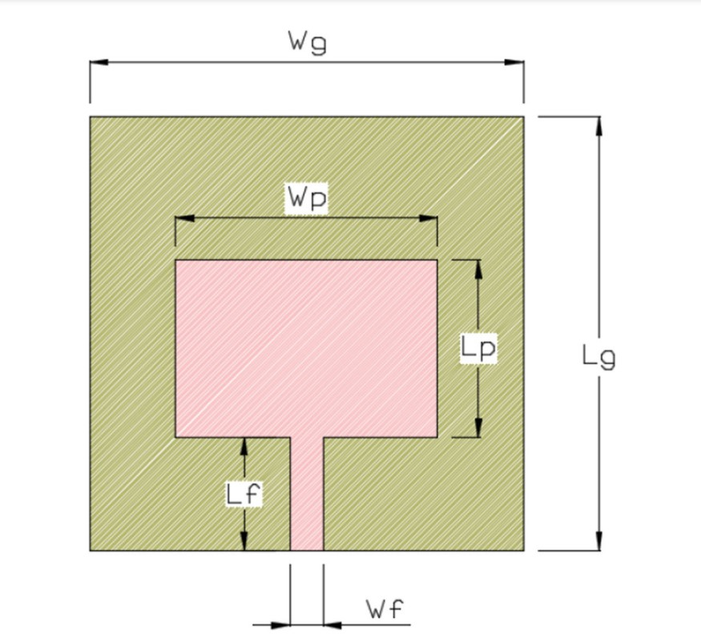

**Figure 1.1: 2D design for the single element MPA**

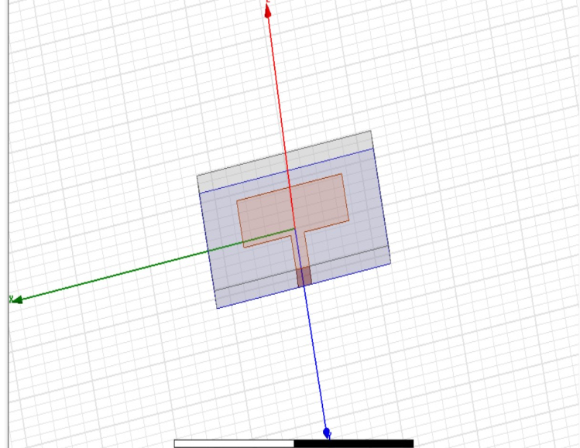

**Figure 1.2: 3D design for the single element MPA**

**Width of the patch:**

The width of the patch is calculated by utilizing the below equation,

Here, Wp is representing the width of the patch, c is representing the speed of light which has the value of 3 108, the resonance frequency is denoted as f r, and ‘’r is representing the dielectric constant value [1].



**Figure 1.3: S11 parameter.**



**Figure 1.4: Gain parameter**

**Task 2:**

Creating a design of MIMO (Multiple Input and Multiple Output) microstrip patch antenna array design in HFSS for frequency(f)=34GHz, display all the resulting parameters.

|  |  |  |  |  |
| --- | --- | --- | --- | --- |
| SL.no | Design parameters | Description | Obtained values | Optimized values |
| 1 | Wp | Width of patch | 3.386 | 3.62 |
| 2 | Lp | Length of patch | 2.551 | 2.45 |
| 3 | Wg | Width of substrate and ground plane | 5.49 | 6 |
| 4 | Lg | Length of substrate and ground plane | 4.65 | 6 |
| 5 | Wf | Width of feed line | 0.46 | 0.46 |
| 6 | Lf | Length of feed line | 1.57 | 1.57 |

**TABLE3.2.1: Obtained and optimized values of design parameters [2]**

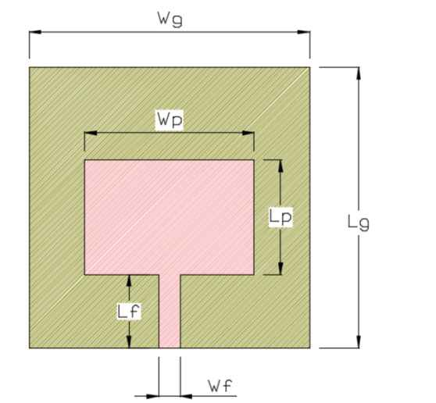

**Figure3.2.1: 2D design for the single element MPA**

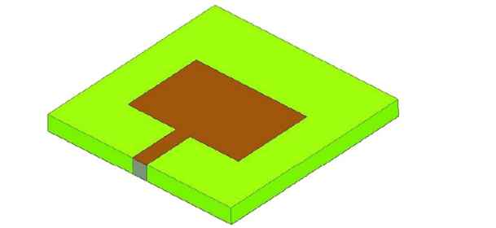

**Figure 3.2.2: 3D design for the single element MPA**

**Width of the patch:**

The width of the patch is calculated by utilizing the below equation,

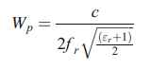

Here, Wp is representing the width of the patch, c is representing the speed of light which has the value of 3 108, the resonance frequency is denoted as f r, and "r is representing the dielectric constant value [2].

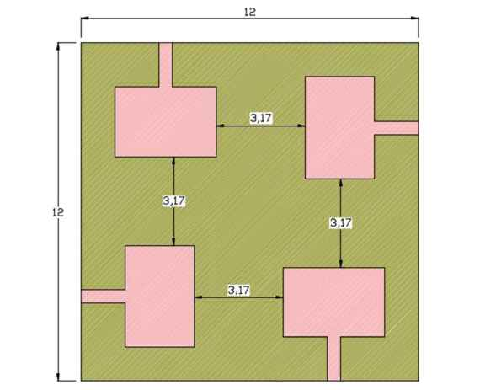

**Figure 3.2.3: 2D design for the proposed circular array MPA**

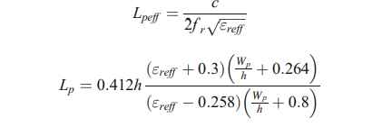

Where, h is representing the thickness of the substrate, the effective dielectric constant is denoted as "reff and it is calculated by utilizing the below equation [2],

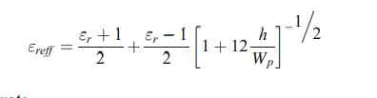

Length of the substrate The length of the substrate is estimated by implementing the following equation,



Where, the length of the substrate is denoted as Lg [2].

**Design and analysis of MPA**

This section performing the design and analysis for the three various types microstrip patch

antenna (MPA) such as Single element MPA, 2 × 2 rectangular array based MPA, and

circular array based MPA. Here, the circular array based MPA is proposed for the 5G wireless

communication. The whole design analysis process is conducted in High-Frequency Structure

Simulation (HFSS) which is the platform of ANSYS software. The designed antennas are

validated by attaining the parameters such as Gain, Return loss, Mutual coupling, VSWR, and

Bandwidth. These parameters values of three MPA design are compared to find the efficient

antenna for the 5G wireless communication. The substrate material and its thickness are

already discussed in Section 3 which applied for the all three MPA designs. The copper

material with 0.0175 mm is utilized for the patch and ground plane. The resonance frequency

for these three-antenna design is taken as 35 GHz which best for the 5G wireless communication.

**Design of single element MPA**

In this section, the single element microstrip patch antenna is design and validated by attaining

the validation parameters such as Gain, return loss, mutual coupling, VSWR, and bandwidth.

Single element antenna contains single patch and single feed line which are utilized as the

transmitter or receiver [2].

The S parameters of the single element Micro Strip Antenna



*Figure3.2.4 :S parameters of single element in micro strip antenna*



*Figure3.2.5: Gain of single element in micro strip antenna*

**Design of proposed circular array MPA**

This section is describing the details about designing methods for the proposed circular array

MPA and its analysis results. Here, also the same designing parameters are used which are

already utilized for the single element MPA and 2 × 2 rectangular array MPA. It also has the

four patches, four feed lines, and four ports. Here, the dimensions of the substrate and the

ground is remaining similar as 2 × 2 rectangular array. The radiation box of the proposed

circular array MPA design is same as 2 × 2 rectangular array MPA. The patches are located as

shown in Fig. 5 and the 3D view of the proposed circular array MPA is shown in Fig. 6.

The design of circular array structure is located over the substrate as shown in Fig. 5. The

steps which are utilized for designing the 2 × 2 rectangular array MPA are utilized for

designing the proposed circular array MPA [2].



**Figure 3.2.6: S parameter of circularized array micro strip array**



**Figure 3.2.7: of circularized array micro strip array**

**Task 3**

Creating a design of Circularly polarized parasitic strips for frequency(f)= in HFSS, display all the resulting parameter.

|  |  |  |  |
| --- | --- | --- | --- |
| Parameters | Values | Parameters | Values |
| L1 | 17.8 | L9 | 6 |
| L2 | 23 | Ls | 55 |
| L3 | 4.5 | W | 3 |
| L4 | 17 | W1 | 2 |
| L5 | 9 | Ws | 50 |
| L6 | 17.8 | Wg | 20 |
| L7 | 6 | D | 1 |
| L8 & Wf | 26 & 0.7 | H | 0.8 |

**Table 3.3.1: Parameters and their respective Values for design**

**Variation in Length of Feed Line (L8)**

To bring out the suitable value for L8 (length of the feed) parametric study is conducted and shows that the |S11| and the axial ratio are sensitive to the variations of L8, When L8 = 24 mm the bandwidth of 3 GHz (2–5 GHz) and ARBW of 1.1 GHz (2–3.1 GHz) is observed but it is not optimum in terms of return loss. For L8 = 26 mm, a single wideband of 3.4 GHz (2–5.4 GHz) and ARBW of2.5 GHz (2.9–5.4 GHz) is obtained. When L8 = 28 mm, Parametric analysis of the proposed antenna by varying length of the feed, L8 in terms of |S11| bandwidth of 3 GHz (2.4–5.4 GHz) and ARBW 1.1 GHz (2–3.1 GHz) is observed, again which is not optimum in terms of impedance bandwidth. Therefore, from the stepwise analysis, it is suggested that the best-suited value for L8 is 26 mm [3].

**Variation in Strip Width (W)**

The stepwise growth of the dimension of strip width (W) is investigated and corresponding results are presented Under the investigation, it is observed Strip Width, W in terms of |S11| that for W = 2 mm two narrow resonating bands of 2–2.4 GHz, and 4.8–5.2 GHz with ARBW of 200 MHz (3.5–3.7 GHz) are obtained. For W = 3 mm, a single wideband of 3.4 GHz (2–5.4 GHz) and ARBW of 2.5 GHz (2.9–5.4 GHz) is obtained. Further increment in the width (W = 4 mm) leads to dual resonance with less 3-dB ARBW of 300 MHz (4.8–5.1 GHz). Consequently, from the perusal of the above investigation, it is observed that W = 3 mm is the optimum width size to achieve the maximum throughput for the proposed antenna [3].

**Variation in the Gap Between the Parasitic Strips (D)**

To enhance the impedance bandwidth of the proposed configurations parametric analysis is carried out in terms of the gap between the parasitic strips (D). Axial ratio variation is also observed. From the perusal it is noted that for D = 1.5 mm and D = 2 mm only one lower frequency band is identified and there is no 3-dB ARBW for D = 1.5 mm and a narrow 3-dB ARBW of 3–4.1 GHz for D = 2 mm. The maximum impedance bandwidth and 3-dB ARBW are achieved for D = 1 mm. Parametric analysis of the proposed antenna by varying the gap between the parasitic strips, D in terms of |S11|which is finalized as the optimum gap between the parasitic strips [3].

**DESIGNING STEPS OF THE ANTENNA:**

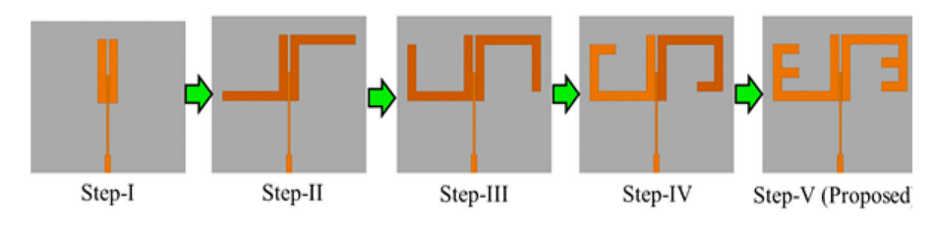

**STEP1:**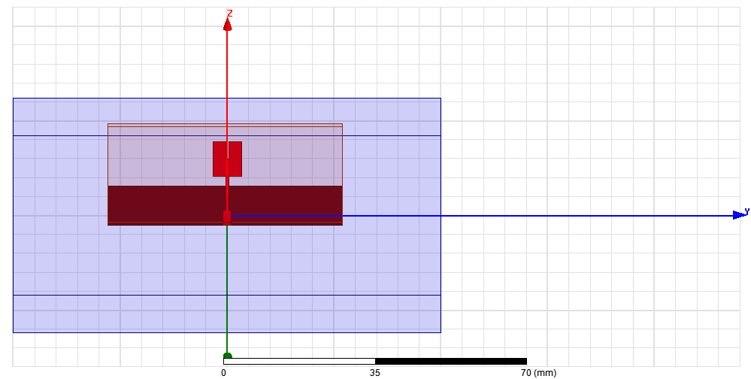



**Figure 3.3.1: design of an antenna****Figure 3.3.2: S parameters of an antenna**

**STEP2:**

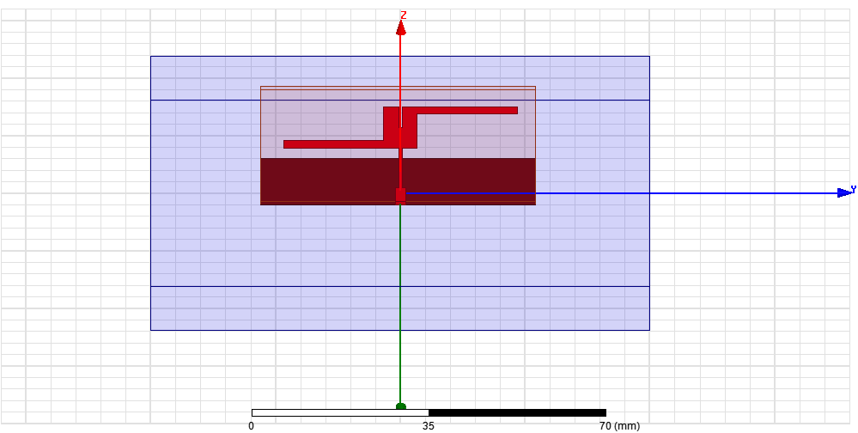

**Figure 3.3.3: design of an antenna****Figure 3.3.4: S parameters of an antenna**

**STEP3:**

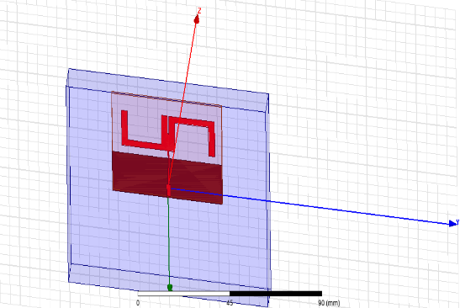

**Figure 3.3.5: design of an antenna****Figure 3.3.6: S parameters of an antenna**

**STEP4:**

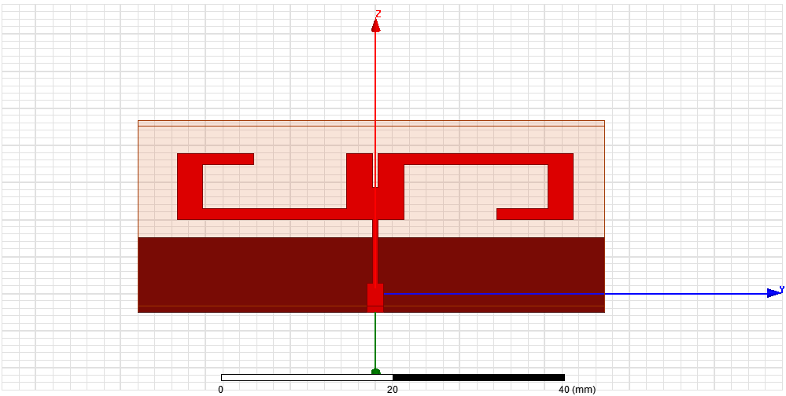

**Figure 3.3.7: design of an antenna****Figure 3.3.8: S parameters of an antenna**

**STEP5:**

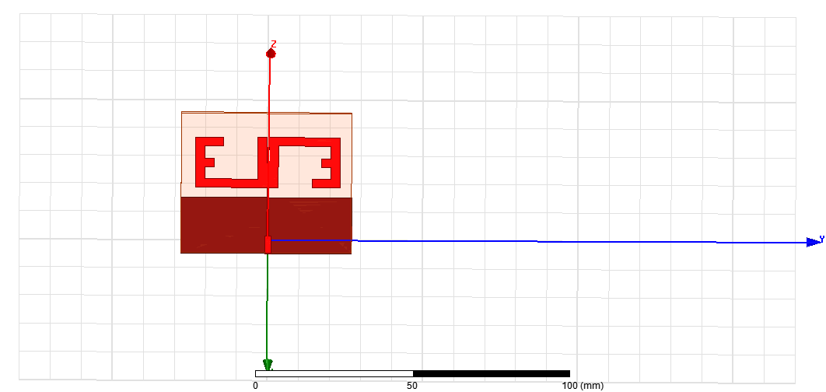 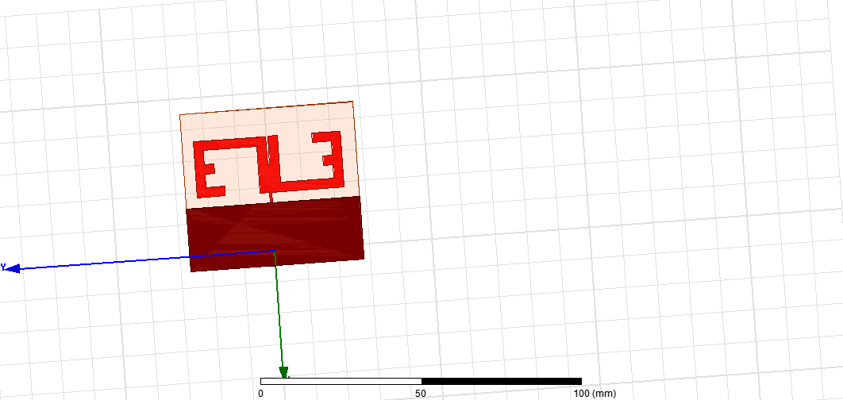

**Figure 3.3.9: Front view of an antenna** **Figure 3.3.10: Back view of an antenna**



**Figure 3.3.11:S parameter of an antenna**



**Figure 3.3.12: Gain of an antenna**

**References:**

1.https://en.wikipedia.org/wiki/Antenna_measurement#:~:text=Typical%20parameters%20of

%20antennas%20are, antenna%20in%20a%20given%20direction.

2. https://doi.org/10.1007/s11042-023-14628-2

3.

4.

5.https://jemengineering.com/blog-intro-to-antenna polarization/#:~:text=Circular%20polarization%20helps%20mitigate%20the,particularly%20effctive%20performance%20and%20gain.

6. https://antennatestlab.com/wp-content/uploads/2017/09/CP-Explained-Without-Math.pdf

7. https://cdn.thomasnet.com/ccp/10014548/223252.pdf

**Conclusion:**

Hence, Real time performance of the antenna can be analyzed in detail by its S-parameter characteristics and its gain value.